[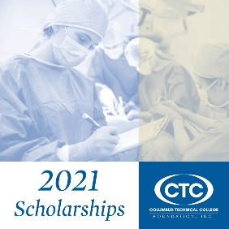](https://online.fliphtml5.com/xywvl/jmbg/)

**CTC Foundation AUTOMOTIVE Scholarship Applications Open for summer semester March 22 – May 25**

The Georgia Automotive Dealers Association Scholarship is available for students enrolled in Automotive or Auto Collision Repair. The scholarship application portal opens Tuesday, March 22. The deadline to apply is 12:00 am (midnight) May 25.

**To apply:**

* Please click here: <https://columbustech.awardspring.com/>
* To log in, use student credentials in the yellow box**.**
* Once logged in, the scholarship opportunity will auto-populate based on your student information on file.

**Requirements:**

Scholarship applicants must meet the following criteria:

* must be enrolled in an Automotive or Auto Collison Repair program (degree, diploma, or TCCs)
* must be registered for summer semester
* minimum 3.0 GPA for current students **(**no GPA requirement for first semester students)
* application includes a written essay
* the scholarship award will be posted directly to the student’s account. It is not a cash award.
* All recipients must participate in Columbus Tech’s virtual awards presentation ceremony by being videotaped and photographed on a designated date and time. Failure to participate forfeits any award.

Again, this scholarship is for automotive and auto collision repair students only.  All majors will be able to apply for scholarship opportunities this fall. Additional information will be provided prior to fall semester.

Please contact Cheryl Metivier at 706 649-1015 or cmetivier@columbustech.edu if you experience technical difficulties.  Often trying a different browser or using a computer instead of a smart phone, or vice versa, takes care of the issue. Please include your phone number and student ID number in your email message.