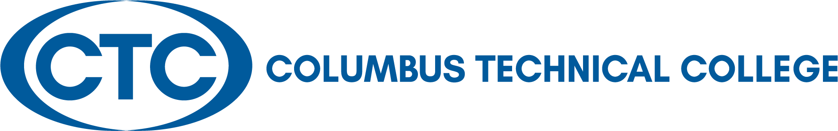

LOCAL BOARD OF DIRECTORS MEETING
January 25, 2022
12:30 p.m. J. Robert Jones Conference Technology Center

A G E N D A

Welcome and Call to Order Travis Chambers

Approval of Minutes for December 9, 2021 Travis Chambers

Columbus Technical College Update Tara Askew

Departments’ Reports via Presentation President’s Leadership Team

Academic Affairs – Kermelle Hensley
Administrative Services – Karen Thomas
Adult Education – April Hopson
Communications – Tara Askew
Economic Development – Jamie Loyd
Institutional Advancement – Susan Sealy
Institutional Effectiveness – Kermelle Hensley
Operations – Tommy Wilson
Student Affairs – Tara Askew

Adjourn Travis Chambers

Local Board of Directors’ Meeting in conjunction
With the Board of Trustee’s Holiday Luncheon
Bibb Mill Event Center
3715 1st Avenue
Columbus, GA 31904

Thursday, December 9, 2021
12:00 p.m.
Board of Directors:

Travis Chambers
Muscogee County

Laura Lee Bernstein
Chattahoochee

Senator Ed Harbison
Muscogee County

Martin Huff
Muscogee County

Isaiah Hugley
Muscogee County

Jon-Erik Jones
Quitman County

Pam Jordan
Talbot County

Judy King
Muscogee County

David Lewis
Muscogee County

Jerald Mitchell
Muscogee County

Sen. Randy Robertson
Harris County

Crystal Shahid
Muscogee County

Rep. Vance Smith
Harris County

James “Jim” Trott
Harris County

Edwina G. Turner
Stewart County

Martha Ann Todd
President

Board Members Present: Travis Chambers, Isaiah Hugley, Jon-Erik Jones, Pam Jordan, Judy King, Crystal Shahid, Vance Smith, Jim Trott, and Edwina Turner

Board Members Absent: Ed Harbison, Martin Huff, David Lewis, Jerald Mitchell, and Randy Robertson

Staff Present: Martha Ann Todd, Kermelle Hensley, April Hopson, Susan Sealy, and Karen Thomas

Approval of Minutes for the Local Board of Directors
Chairman Chambers called for any corrections to the minutes as written. After hearing none, he asked for a motion to approve the September 28, 2021 minutes. Upon appropriate motion and second, the minutes were approved.

Old Business – None

New Business – None

Adjourn: There being no other business for discussion, upon appropriate motion and second, the Board adjourned at 12:30 p.m. The date of the next Board meeting is scheduled for January 25, 2022.

Minutes respectfully submitted by: Mary Alexander, President’s Office

